|  |  |
| --- | --- |
| **Name** | Muhammad Arslan Raza |
| **Section** | A |
| **Roll no.** | 2020-EE-403 |

**Lab 9**

**Experiment no. 8**

**Effect of pre-heater on bench top of Cooling Tower Trainer**

**Introduction**

Cooling tower is an important part of power plant. The basic working principle of cooling tower is to cool the hot water with the help of atmospheric air. A water store unit called pond is placed at the base of the cooling tower. **Cooling towers are a special type of** heat exchanger that allows water and air to come in contact with each other to lower the temperature of the hot water. During this process, small volumes of water evaporate, lowering the temperature of the water that’s being circulated throughout the cooling tower. Purpose of a **cooling tower** is to reduce the temperature of circulating hot water to re-use this water again. This hot water is coming from the condenser. In [steam power plant](http://www.mechanicaltutorial.com/introduction-and-types-of-thermal-power-plant), cooling tower first collects hot water from the condenser at a certain height from the ground level, after that the hot water falls down by the radial spray. The atmospheric air which is comparatively cool enters at the bottom of the tower. Now the hot air in the cooling tower expose in the atmospheric air which reduces the temperature of the hot water by partial evaporation. This cooled water is collected in the pond at the base of the tower and pumped into the condenser for further use.

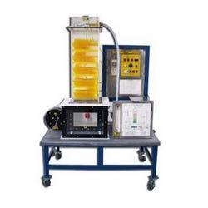

Figure no. 9.1: Model of Cooling Tower trainer

**Parts list and details:**

Following are the parts of cooling tower for this experiment:

* Condenser tank
* Water flow meter
* Water distributor
* Fills/Columns
* Cold water basin
* Air distributor chamber
* Float valve
* Bleed valve
* Water pump
* Water filter
* Make up water tank
* Anemometer
* Air pre-heater

**Air pre-heater:**

Air pre-heater are installed in air distributor chamber to heat the atmospheric air before it goes to cooling tower. This feature of cooling tower allows us to pre heat air in winter to get the summer conditions.

**Explanation:**

Firstly, **0.5kW air pre-heater** is on which heats the air. Water from condenser enters the cooling tower and after passing through water pump, water filter and water flow meter, it enters the water distributor which spreads the water and increases its surface area so that maximum cooling occur on contact with air. The water is released over fills or columns and air is drawn upward through air distributor tank. Water air contact occur and evaporation takes place. Air goes out from air outlet or from blower. The cold water is collected in the basin and from this back to condenser. As air is at high temperature, so less heat exchange occurs between air and water and decrease of water temperature is less as compared to when normal atmospheric air enters the tower.

Then, **1kW air pre-heater** is on which heats the air. Water from condenser enters the cooling tower and after passing through water pump, water filter and water flow meter, it enters the water distributor which spreads the water and increases its surface area so that maximum cooling occur on contact with air. The water is released over fills or columns and air is drawn upward through air distributor tank. Water air contact occur and evaporation takes place. Air goes out from air outlet or from blower. The cold water is collected in the basin and from this back to condenser. As air is at higher temperature, so less heat exchange occurs between air and water and decrease of water temperature is very less as compared to when normal atmospheric air enters the tower or air enters the tower after heated by 0.5kW pre-heater.

This is how cooling tower working decreases in summer season due to high temperature of atmospheric air.

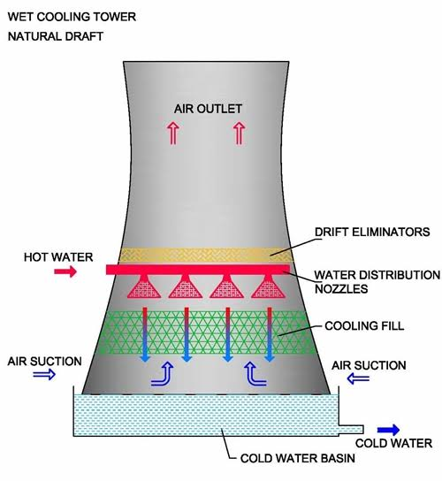

Figure no. 9.2: Working of cooling tower

**Readings:**

T1= Air inlet temperature (Dry bulb)

T2= Air inlet temperature (Wet bulb)

T3= Air outlet temperature (Dry bulb)

T4= Air outlet temperature (Wet bulb)

T5= Cooling Tower water inlet temperature

T6= Cooling Tower water outlet temperature

T7= Make up water temperature

Range= T5-T6

Approach= T6-T2

Effectiveness= range/range+approach

**For 0.5kW heater:**

|  |  |  |  |  |  |  |  |  |  |  |  |
| --- | --- | --- | --- | --- | --- | --- | --- | --- | --- | --- | --- |
| Velocity  (m/s) | Flow rate  (m3/s) | Temperature (oC) | | | | | | | Range  (oC) | Approach  (oC) | Effectiveness |
| T1 | T2 | T3 | T4 | T5 | T6 | T7 |
| 6.5 | 9 | 21 | 22 | 22 | 23 | 24 | 23 | 13 | 1 | 1 | 50% |

**For 1kW heater:**

|  |  |  |  |  |  |  |  |  |  |  |  |
| --- | --- | --- | --- | --- | --- | --- | --- | --- | --- | --- | --- |
| Velocity  (m/s) | Flow rate  (m3/s) | Temperature (oC) | | | | | | | Range  (oC) | Approach  (oC) | Effectiveness |
| T1 | T2 | T3 | T4 | T5 | T6 | T7 |
| 6.5 | 9 | 25 | 20 | 22 | 22 | 23 | 21 | 13 | 2 | 1 | 66% |

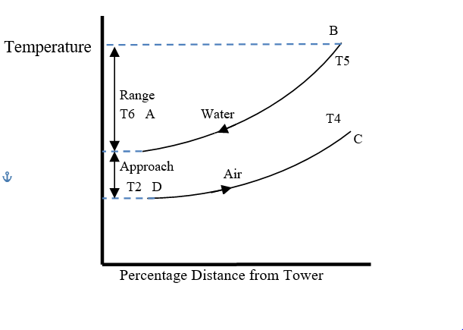

Figure no. 9.3: Temperature Relationship Between Water and Air in Cooling Tower

**Application:**

Common applications include cooling the circulating water used in:

* Oil refineries
* Petrochemical plants
* Thermal power stations
* Nuclear power station
* HVAC systems
* Heavy industries